Hi Gary

I collected the problems that exist in the current system. I send them to you. If you have time, please modify these as quickly as possible. At this point, all project data is ready. We hope to use this system as soon as possible.

1. Product prices cannot follow changes in the supermarket server system. For example，Sriracha(2446306316) raised the price from $6.99 to $15.99 two months ago. Unfortunately, I still see the old prices in my computer.

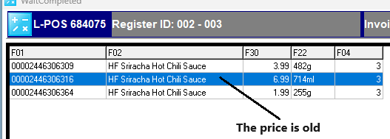

2. When I make the order, the product price is less than $1 and the price could not be modified. The system prompts that the product cannot be sold below the cost price.

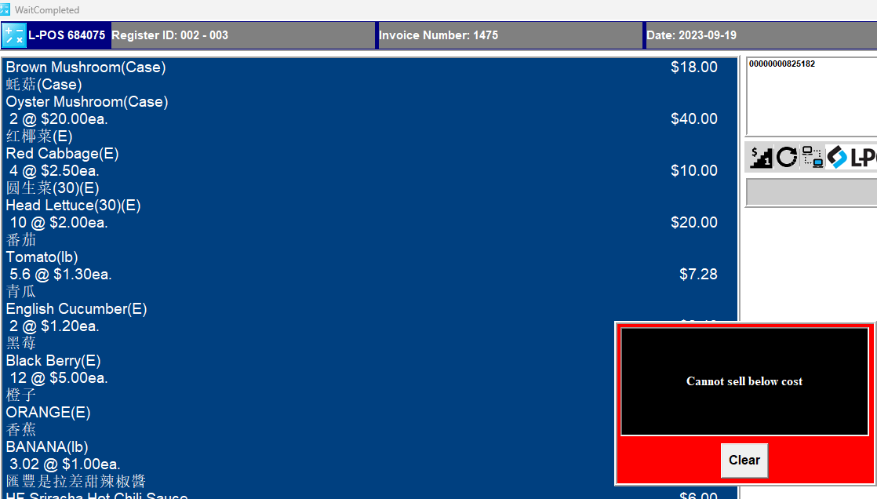

3. The soft keyboard covers the query results, please remove it

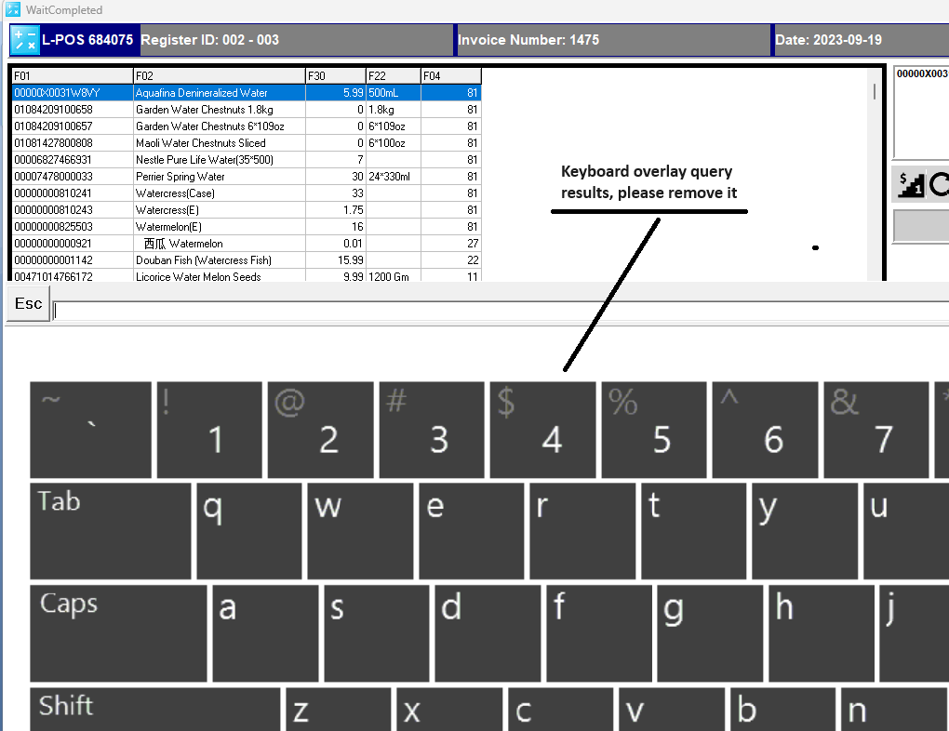

4. The Packing Slip needs to be changed to the following format

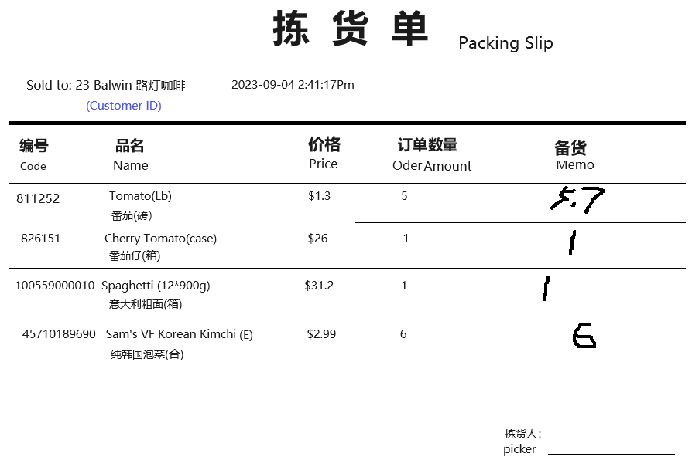

5. The invoice head need a picture. (see the sample below)

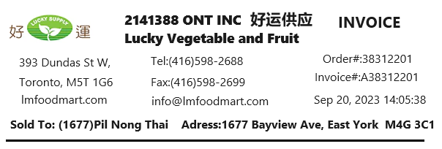

6. If the product is not for sale, it will not appear in product search results(See the item pic)

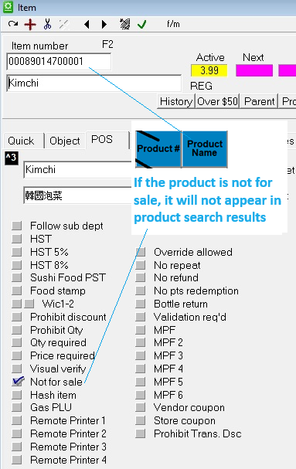

7. Product # and Customer Name inquiry do not work

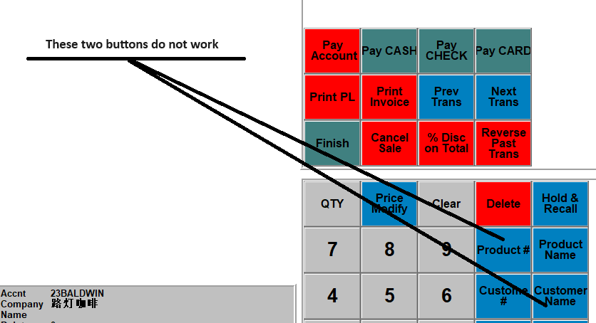

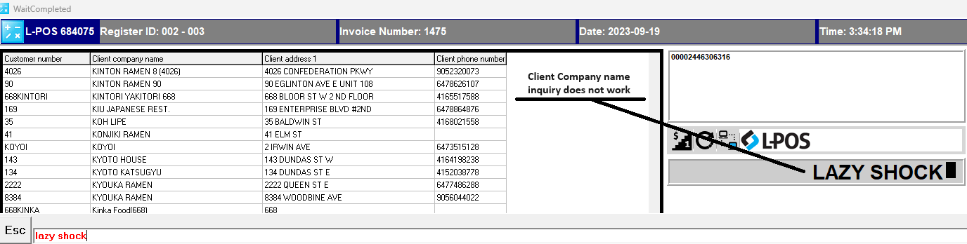

8. Refund: Some goods in the invoice are sold at a change price, but their prices cannot be changed when returning goods.

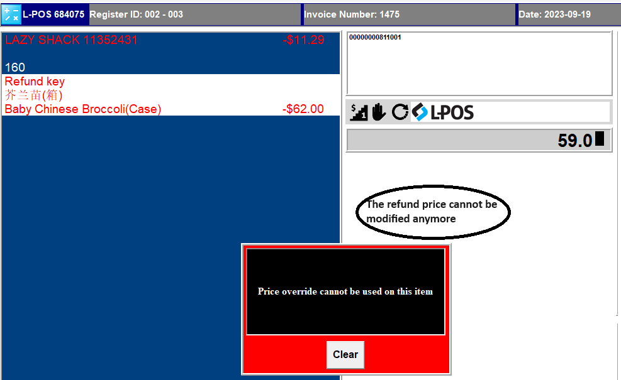

9.Refund: Items cannot be deleted when a refund orders is making

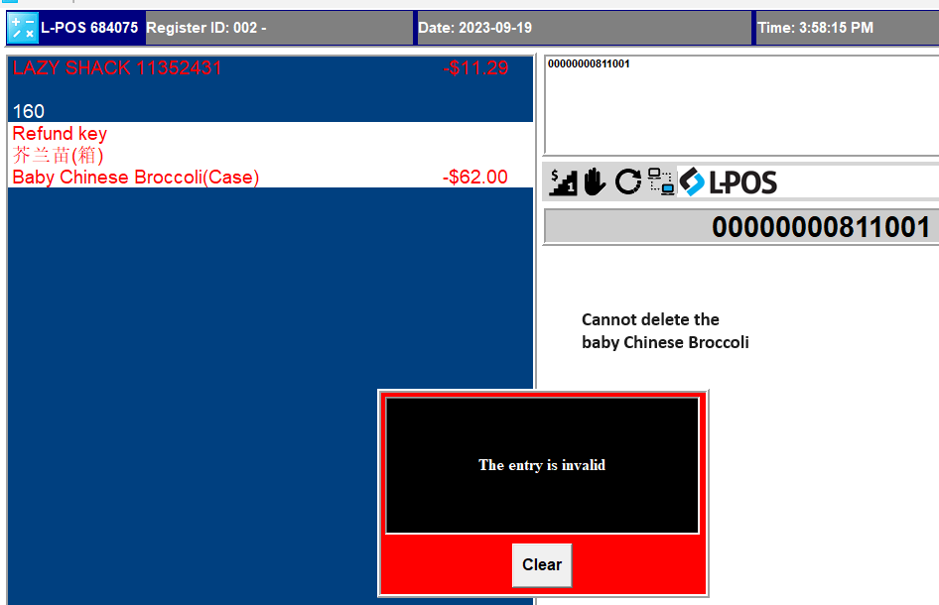

10. Report:

8.1 Clients -> Statement by email, Mailing Label, Error message “Nothing to print”

8.2 List -> PLU List bug

When the report results exceed 300 pages, the system freezes.